1.2 Safeguarding children, young people and vulnerable adults

Policy statement

Our setting will work with children, parents and the community to ensure the rights and safety of children, young people* and vulnerable adults. Our Safeguarding Policy is based on the three key commitments of the Early Years Alliance Safeguarding Children Policy.

Procedures

We carry out the following procedures to ensure we meet the three key commitments of the Alliance Safeguarding Children Policy, which incorporates responding to child protection concerns.

Key commitment 1
We are committed to building a 'culture of safety' in which children, young people and vulnerable adults are protected from abuse and harm in all areas of our service delivery.

- Group provision: Our Designated Safeguarding Lead (a member of staff) who co-ordinates child, young person and vulnerable adult protection issues is:
Stacey Enever
- When the setting is open but the designated person is not on site, a suitably trained deputy is available at all times for staff to discuss safeguarding concerns.

- Our Trustee Designated Safeguarding Lead (a member of the management team) who oversees this work is:
John Barker- Chair of Trustees
- The Designated Safeguarding Lead and Trustee Safeguarding Lead ensure they have relevant links with statutory and voluntary organisations with regard to safeguarding.
- The Designated Safeguarding Lead and Trustee Safeguarding Lead understand Telford and Wrekin Safeguarding Partnership safeguarding procedures, attends relevant TWSP training at least every two years and refreshes their knowledge of safeguarding at least annually.
- We ensure all staff are trained to understand our safeguarding policies and procedures and that parents are made aware of them too.
- All staff understand that safeguarding is their responsibility.
- All staff have an up-to-date knowledge of safeguarding issues, are alert to potential indicators and signs of abuse and neglect and understand their professional duty to ensure safeguarding and child protection concerns are reported to the local authority children’s social care team or the NSPCC. They receive updates on safeguarding at least annually.
- All staff are confident to ask questions in relation to any safeguarding concerns and know not to just take things at face value but can be respectfully sceptical.
- All staff understand the principles of early help (as defined in Working Together to Safeguard Children, 2023) and are able to identify those children and families who may be in need of early help and enable them to access it.
- All staff understand the thresholds of significant harm and understand how to access services for families, including for those families who are below the threshold for significant harm, according to arrangements published by Telford and Wrekin Safeguarding Partnership.
- All staff understand their responsibilities under the General Data Protection Regulation and the Data Protection Act 2018, and understand relevant safeguarding legislation, statutory requirements and local safeguarding partner requirements and ensure that any information they may share about parents and their children with other agencies is shared appropriately and lawfully.
- We will support families to receive appropriate early help by sharing information with other agencies in accordance with statutory requirements and legislation.
- We will share information lawfully with safeguarding partners and other agencies where there are safeguarding concerns.
- We will be transparent about how we lawfully process data.
- All staff understand how to escalate their concerns in the event that they feel either the local authority and/or their own organisation has not acted adequately to safeguard and know how to follow local safeguarding procedures to resolve professional disputes between staff and organisations.
- All staff understand what the organisation expects of them in terms of their required behaviour and conduct, and follow our policies and procedures on positive behaviour, online safety (including use of cameras and mobile phones), whistleblowing and dignity at work.
- Children have a key person to build a relationship with, and are supported to articulate any worries, concerns or complaints that they may have in an age appropriate way.
- All staff understand our policy on promoting positive behaviour and follow it in relation to children showing aggression towards other children.
- Adequate and appropriate staffing resources are provided to meet the needs of children.
- Applicants for posts within the setting are clearly informed that the positions are exempt from the Rehabilitation of Offenders Act 1974.
- Enhanced criminal records and barred lists checks and other suitability checks are carried out for staff and volunteers prior to their post being confirmed, to ensure that no disqualified person or unsuitable person works at the setting or has access to the children.
- Where applications are rejected based on information disclosed, applicants have the right to know and to challenge incorrect information.
- Enhanced criminal records and barred lists checks are carried out on anyone living or working on the premises.
- Volunteers must:
  - be aged 17 or over;
  - be considered competent and responsible;
  - receive a robust induction and regular supervisory meetings;
  - be familiar with all the settings policies and procedures;
  - be fully checked for suitability if they are to have unsupervised access to the children at any time.
- Information is recorded about staff qualifications, and the identity checks and vetting processes that have been completed including:
- the criminal records disclosure reference number;
- certificate of good conduct or equivalent where a UK DBS check is not appropriate;
- the date the disclosure was obtained; and
- details of who obtained it.
- All staff and volunteers are informed that they are expected to disclose any convictions, cautions, court orders or reprimands and warnings which may affect their suitability to work with children (whether received before or during their employment with us).
- From 31 August 2018, staff and volunteers in childcare settings that are not based on domestic premises are not required to notify their line manager if anyone in their household (including family members, lodgers, partners etc.) has any relevant convictions, cautions, court orders, reprimands or warnings or has been barred from, or had registration refused or cancelled in relation to any childcare provision or have had orders made in relation to care of their children. For childminders and childcare provided from domestic settings they will be required to notify if anyone in their household has any relevant convictions, court orders or reprimands or had registration refused or cancelled in relation to childcare provision or have had certain Orders made in relation to the care of their children in accordance with the Childcare Disqualification and Childcare Regulations 2018, and Disqualification under the Childcare Act guidance effective from 31 August 2018.
- Staff receive regular supervision, which includes discussion of any safeguarding issues, and their performance and learning needs are reviewed regularly.
- In addition to induction and supervision, staff are provided with clear expectations in relation to their behaviour.
- We notify the Disclosure and Barring Service of any person who is dismissed from our employment, or resigns in circumstances that would otherwise have led to dismissal for reasons of a child protection concern.
- Procedures are in place to record the details of visitors to the setting.
- Security steps are taken to ensure that we have control over who comes into the setting so that no unauthorised person has unsupervised access to the children.
- Steps are taken to ensure children are not photographed or filmed on video for any other purpose than to record their development or their participation in events organised by us. Parents sign a consent form and have access to records holding visual images of their child. Staff do not use personal cameras, mobile phones or any other type of filming equipment to record images.
- Personal mobile phones are not used where children are present.
- The designated person in the setting has responsibility for ensuring that there is an adequate online safety policy in place.
- We keep a written record of all complaints and concerns including details of how they were responded to.
- We ensure that robust risk assessments are completed, that they are seen and signed by all relevant staff and that they are regularly reviewed and updated, in line with our health and safety policy.
- The designated officer will support the designated person to undertake their role adequately and offer advice, guidance, supervision and support.
- The designated person will inform the designated officer at the first opportunity of every significant safeguarding concern, however this should not delay any referrals being made to children’s social care, or where appropriate, the LADO, OFSTED or RIDDOR.

Key commitment 2
We are committed to responding promptly and appropriately to all incidents, allegations or concerns of abuse that may occur and to work with statutory agencies in accordance with the procedures that are set down in 'What to do if you’re worried a child is being abused' (HMG, 2015) and the Care Act 2014.

Responding to suspicions of abuse
- We acknowledge that abuse of children can take different forms - physical, emotional, sexual, neglect, and also taking into account child on child abuse.
- We ensure that all staff have an understanding of the additional vulnerabilities that arise from special educational needs and/or disabilities, plus inequalities of race, gender, language, religion, sexual orientation or culture, and that these receive full consideration in relation to child, young person or vulnerable adult protection.
- When children are suffering from physical, sexual or emotional abuse, or experiencing neglect, this may be demonstrated through:
- significant changes in their behaviour;
- deterioration in their general well-being;
- their comments which may give cause for concern, or the things they say (direct or indirect
- disclosure);
- changes in their appearance, their behaviour, or their play;
- unexplained bruising, marks or signs of possible abuse or neglect; and
- any reason to suspect neglect or abuse outside the setting.
  - We understand how to identify children who may be in need of early help, how to access services for them
- We understand that we should refer a child who meets the s17 Children Act 1989 “child in need” definition to local authority children’s social work services
- We understand that we should refer any child who may be at risk of significant harm to local authority children’s social work services.
- We are aware of the ‘hidden harm’ agenda concerning parents with drug and alcohol problems and consider other factors affecting parental capacity and risk, such as social exclusion, domestic violence, radicalisation, mental or physical illness and parent’s learning disability.
- We are aware that children’s vulnerability is potentially increased when they are privately fostered and when we know that a child is being cared for under a private fostering arrangement, we inform our local authority children’s social care team.
- We are prepared to take action if we have concerns about the welfare of a child who fails to arrive at a session when expected. The DSL will take immediate action to contact the child’s parent to seek an explanation for the child’s absence and be assured that the child is safe and well. If no contact is made with the child’s parents and the DSL has reason to believe that the child is at risk of significant harm, the relevant professionals are contacted immediately and TWSP procedures are followed. If the child has current involvement with social care the social worker is notified on the day of the unexplained absence.
- We are aware of other factors that affect children’s vulnerability that may affect, or may have affected, children and young people using our provision, such as abuse of children who have special educational needs and/or disabilities; fabricated or induced illness; child abuse linked to beliefs in spirit possession; honour based abuse, sexual exploitation of children, including through internet abuse; Female Genital Mutilation and radicalisation or extremism.
- In relation to radicalisation and extremism, we follow the Prevent Duty guidance for England and Wales published by the Home Office and LSCB procedures on responding to radicalisation.
- The designated person completes online Channel training, online Prevent training and attends local WRAP training where available to ensure they are familiar with the local protocol and procedures for responding to concerns about radicalisation.
- We are aware of the mandatory duty that applies to teachers, and health workers to report cases of Female Genital Mutilation to the police. We are also aware that early years practitioners should follow local authority published safeguarding procedures to respond to FGM and other safeguarding issues, which involves contacting police if a crime of FGM has been or may be about to be committed.
- We also make ourselves aware that some children and young people are affected by gang activity, by complex, multiple or organised abuse, through forced marriage or honour based violence or may be victims of child trafficking. While this may be less likely to affect young children in our care, we may become aware of any of these factors affecting older children and young people who we may come into contact with.
- If we become concerned that a child may be a victim of modern slavery or human trafficking we will refer to the National Referral Mechanism, as soon as possible and refer and/or seek advice to the local authority children’s social work service and/or police.
- We will be alert to the threats children may face from outside their families, such as that posed by organised crime groups such as county lines and child sexual exploitation, online use and from within peer groups and the wider community.
- Where we believe that a child in our care or that is known to us may be affected by any of these factors we follow the procedures below for reporting child protection and child in need concerns and follow the TWSP procedures.
- Where such indicators are apparent, the child's key person makes a dated record of the details of the concern and discusses what to do with the member of staff who is acting as the designated person. The information is stored on the child's personal file.
- In the event that a staff member or volunteer is unhappy with the decision made of the designated person in relation to whether to make a safeguarding referral they must follow escalation procedures.
- We refer concerns about children’s welfare to the local authority children’s social care team and co-operate fully in any subsequent investigation. NB In some cases this may mean the police or another agency identified by Telford and Wrekin Safeguarding Partnership.
- We respond to any disclosures sensitively and appropriately and take care not to influence the outcome either through the way we speak to children or by asking questions of children (although we may check out/clarify the details of what we think they have told us with them).
- We take account of the need to protect young people aged 16-19 as defined by the Children Act 1989. This may include students or school children on work placement, young employees or young parents. Where abuse or neglect is suspected we follow the procedure for reporting any other child protection concerns. The views of the young person will always be taken into account in an age appropriate way, but the setting may override the young person’s refusal to consent to share information if it feels that it is necessary to prevent a crime from being committed or intervene where one may have been, or to prevent harm to a child or adult. Sharing confidential information without consent is done only where not sharing it could be worse than the outcome of having shared it.
- All staff are also aware that adults can also be vulnerable and know how to refer adults who are in need of community care services.
- All staff know that they can contact the NSPCC whistleblowing helpline if they feel that or organisation and the local authority have not taken appropriate action to safeguard a child and this has not been addressed satisfactorily through organisational escalation and professional challenge procedures.
- We have a whistleblowing policy in place.
- Staff/volunteers know they can contact the organisation Public Concern at Work for advice relating to whistleblowing dilemmas.

Recording suspicions of abuse and disclosures
- Where a child makes comments to a member of staff that give cause for concern (disclosure), or a member of staff observes signs or signals that give cause for concern, such as significant changes in behaviour; deterioration in general well-being; unexplained bruising, marks or signs of possible abuse or neglect; that member of staff:
- listens to the child, offers reassurance and gives assurance that she or he will take action;
- does not question the child, although it is OK to ask questions for the purposes of clarification;
- makes a written record that forms an objective record of the observation or disclosure that includes: the date and time of the observation or the disclosure; the exact words spoken by the child as far as possible; the name of the person to whom the concern was reported, with the date and time; and the names of any other person present at the time.
- These records are signed and dated and kept in the child's personal file, which is kept securely and confidentially.
- The DSL is informed of the issue at the earliest opportunity, and always within one working day.
- Where the Local Safeguarding Children Board or local safeguarding partners safeguarding procedures stipulates the process for recording and sharing concerns, we include those procedures alongside this procedure and follow the steps set down by Telford and Wrekin Safeguarding Partnership.

Making a referral to the local authority children's social care team
- The Early Years Alliance's publication “Safeguarding Children” contains procedures to help in making a referral to the local children's social care team, as well as template forms for recording concerns and to assist with making a referral.
- We keep a copy of this document alongside the procedures for recording and reporting set down by our Local Safeguarding Children Board, which we follow where local procedures differ from those of the Early Years Alliance.

Escalation process
- If we feel that a referral made has not been dealt with properly or that concerns are not being addressed or responded to, we will follow the TWSP escalation process.
- We will ensure that staff are aware of how to escalate concerns.
- We will follow local procedures published by the TWSP to resolve professional disputes.

Informing parents
- Parents are normally the first point of contact. Concerns are normally discussed with parents to gain their view of events, unless it is felt that this may put the child or other person at risk, or may interfere with the course of a police investigation, or may unduly delay the referral, or unless it is otherwise unreasonable to seek consent. Advice will be sought from social care, or in some circumstances police, where necessary.
- Parents are informed when we make a record of concerns in their child’s file and that we also make a note of any discussion we have with them regarding a concern.
- If a suspicion of abuse warrants referral to social care, parents are informed at the same time that the referral will be made, except where the procedures of the Telford and Wrekin Safeguarding Partnership does not allow this, for example, where it is believed that the child may be placed at risk.
- This will usually be the case where the parent is the likely abuser or where sexual abuse may have occurred.
- If there is a possibility that advising a parent beforehand may place a child at greater risk (or interfere with a police response) the DSL should consider seeking advice from children’s social care, about whether or not to advise parents beforehand, and should record and follow the advice given.

Liaison with other agencies and multi-agency working
- We work within the Telford and Wrekin Safeguarding Partnership guidelines.
- The current version of ‘What to do if you’re worried a child is being abused’ is available for parents and staff and all staff are familiar with what they need to do if they have concerns.
- We have procedures for contacting the local authority regarding child protection issues and concerns about children’s welfare, including maintaining a list of names, addresses and telephone numbers of social workers, to ensure that it is easy, in any emergency, for the setting and children's social care to work well together.
- We notify OFSTED of any incident or accident and any changes in our arrangements which may affect the well-being of children or where an allegation of abuse is made against a member of staff (whether the allegations relate to harm or abuse committed on our premises or elsewhere). Notifications to OFSTED are made as soon as is reasonably practicable, but at the latest within 14 days of the allegations being made.
- Contact details for the local National Society for the Prevention of Cruelty to Children (NSPCC) are also kept.

Allegations against staff and persons in position of trust
- We ensure that all parents know how to complain about the behaviour or actions of staff or volunteers within the setting, or anyone living or working on the premises occupied by the setting, which may include an allegation of abuse.
- We ensure that all staff volunteers and anyone else working in the setting knows how to raise concerns that they may have about the conduct or behaviour of other people including staff/colleagues.
- We differentiate between allegations, and concerns about the quality of care or practice and complaints and have a separate process for responding to complaints.
- We respond to any inappropriate behaviour displayed by members of staff, volunteer or any other person living or working on the premises, which includes:
- inappropriate sexual comments;
- excessive one-to-one attention beyond the requirements of their usual role and responsibilities, or inappropriate sharing of images
- We will recognise and respond to allegations that a person who works with children has:
  - behaved in a way that has harmed a child, or may have harmed a child
  - possibly committed a criminal offence against or related to a child
  - behaved towards a child or children in a way that indicates they may pose a risk of harm to children
- We respond to any concerns raised by staff and volunteers who know how to escalate their concerns if they are not satisfied with our response
- We respond to any disclosure by children or staff that abuse by a member of staff or volunteer within the setting, or anyone living or working on the premises occupied by the setting, may have taken, or is taking place, by first recording the details of any such alleged incident.
- We refer any such complaint immediately to a senior manager within the organisation and the Local Authority Designated Officer (LADO) as necessary to investigate and/or offer advice:
Glenn Ashbrook 01952 385385
- We also report any such alleged incident to OFSTED (unless advised by LADO that this is unnecessary due to the incident not meeting the threshold), as well as what measures we have taken. We are aware that it is an offence not to do this.
- We co-operate entirely with any investigation carried out by children’s social care in conjunction with the police.
- Where the management team and children’s social care agree it is appropriate in the circumstances, the member of staff or volunteer will be suspended for the duration of the investigation. This is not an indication of admission that the alleged incident has taken place, but is to protect the staff, as well as children and families, throughout the process. Where it is appropriate and practical and agreed with the LADO, we will seek to offer an alternative to suspension for the duration of the investigation, if an alternative is available that will safeguard children and not place the affected staff or volunteer at risk.

Disciplinary action
Where a member of staff or volunteer has been dismissed due to engaging in activities that caused concern for the safeguarding of children or vulnerable adults, we will notify the Disclosure and Barring Service of relevant information, so that individuals who pose a threat to children and vulnerable groups can be identified and barred from working with these groups.

Key commitment 3
We are committed to promoting awareness of child abuse issues throughout our training and learning programmes for adults. We are also committed to empowering children through our early childhood curriculum, promoting their right to be strong, resilient and listened to.

Training
- Training opportunities are sought for all adults involved in the setting to ensure that they are able to recognise the signs and signals of possible physical abuse, emotional abuse, sexual abuse (including child sexual exploitation) and neglect and that they are aware of the local authority guidelines for making referrals. Training opportunities should also cover extra familial threats such as online risks, radicalisation and grooming, and how to identify and respond to families who may be in need of early help, and organisational safeguarding procedures.
- Designated persons receive appropriate training, as recommended by the Telford and Wrekin Safeguarding Partnership every two years and refresh their knowledge and skills at least annually.
- We ensure that all staff know the procedures for reporting and recording any concerns they may have about the provision.
- We ensure that all staff receive updates on safeguarding via emails, newsletters, online training and/or discussion at staff meetings at least once a year.

Planning
- No child is left alone with staff or volunteers in a one-to-one situation without being within sight and/or hearing of other staff or volunteers.

Curriculum
- We introduce key elements of keeping children safe into our programme to promote the personal, social and emotional development of all children, so that they may grow to be strong, resilient and listened to and so that they develop an understanding of why and how to keep safe.
- We create within the setting a culture of value and respect for individuals, having positive regard for children's heritage arising from their colour, ethnicity, languages spoken at home, cultural and social background.
- We ensure that this is carried out in a way that is developmentally appropriate for the children.

Confidentiality
- All suspicions and investigations are kept confidential and shared only with those who need to know. Any information is shared under the guidance of Telford and Wrekin Safeguarding Partnership and in line with the GDPR, Data Protection Act 2018, and Working Together to Safeguard Children 2023.

Support to families
- We believe in building trusting and supportive relationships with families, staff and volunteers.
We make clear to parents our role and responsibilities in relation to child protection, such as for the reporting of concerns, information sharing, monitoring of the child, and liaising at all times with the local children’s social care team.
- We will continue to welcome the child and the family whilst investigations are being made in relation to any alleged abuse.
- We follow the Child Protection Plan as set by the child’s social worker in relation to the setting's designated role and tasks in supporting that child and their family, subsequent to any investigation.
- We will engage with any “child in need” plan or “early help” plan as agreed.
- Confidential records kept on a child are shared with the child's parents or those who have parental responsibility for the child in accordance with the Confidentiality and Client Access to Records procedure, and only if appropriate under the guidance of Telford and Wrekin Safeguarding Partnership.

Legal framework

Primary legislation
- Children Act (1989 s47)
- Protection of Children Act (1999)
- The Children Act (2004 s11)
- Children and Social Work Act 2017
- Safeguarding Vulnerable Groups Act (2006)
- Childcare Act (2006)
- Child Safeguarding Practice Review and Relevant Agency (England) Regulations 2018

Secondary legislation
- Sexual Offences Act (2003)
- Criminal Justice and Court Services Act (2000)
- Equality Act (2010)
- General Data Protection Regulations (GDPR) (2018)
- Childcare (Disqualification) Regulations (2009)
- Children and Families Act (2014)
- Care Act (2014)
- Serious Crime Act (2015)
- Counter-Terrorism and Security Act (2015)

Further guidance

- Working Together to Safeguard Children (HMG, 2023)
- What to do if you’re Worried a Child is Being Abused (HMG, 2015)
- Framework for the Assessment of Children in Need and their Families (DoH 2000)
- The Common Assessment Framework for Children and Young People: A Guide for Practitioners
(CWDC 2010)
- Statutory guidance on making arrangements to safeguard and promote the welfare of children under section 11 of the Children Act 2004 (HMG 2008)
- Hidden Harm – Responding to the Needs of Children of Problem Drug Users (ACMD, 2003)
- Information Sharing: Advice for Practitioners providing Safeguarding Services (DfE 2018)
- Disclosure and Barring Service: www.gov.uk/disclosure-barring-service-check
- Revised Prevent Duty Guidance for England and Wales (HMG, 2024)
- Inspecting Safeguarding in Early Years, Education and Skills Settings, (OFSTED, 2023)

This policy was adopted by | Priorslee Pre-School | (name of provider)
On | 7th April 2025 | (date)
Date to be reviewed | April 2026 | (date)
Signed on behalf of the provider | 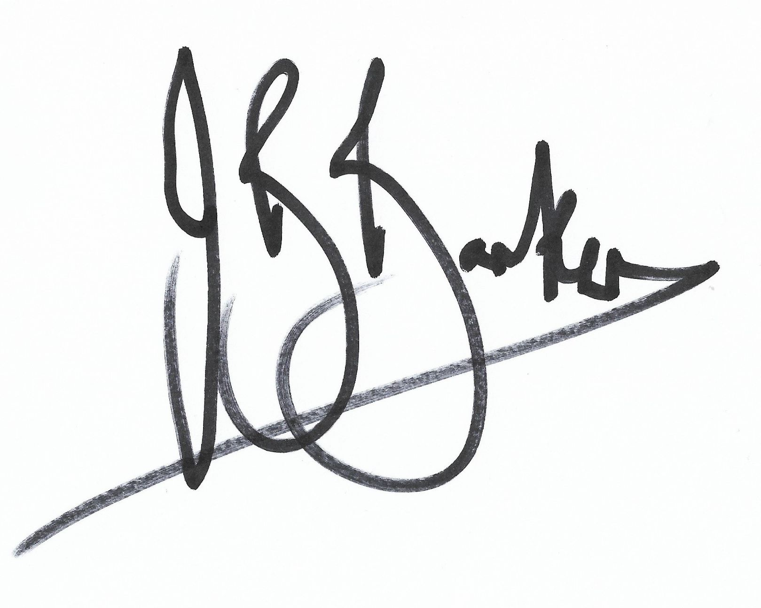
Name of signatory | John Barker
Role of signatory (e.g. chair, director or owner) | Chair

Other useful Early Years Alliance publications

- Safeguarding Children (2013)
- Safeguarding through Effective Supervision (2013)
- The New Early Years Employee Handbook (2016)
- People Management in the Early Years (2016)

*A ‘young person’ is defined as 16 to 19 years old – in our setting they may be a student, worker, volunteer or parent.

