Priorslee Pre-School Visitors Policy (Covid19)….18/09/2020

What actions do we need to take in order mitigate risk in at our premises?
People visiting our premises

Potential Covid-19 Symptoms?

- No person should attend our premises if they or a member of their household is showing any of the symptoms for Covid-19 or if they have been told to self-isolate by the Government.
- Every person wishing to enter our premises must undergo a temperature check. If the visitors temperature is shown to be higher than 37.8 degrees on THREE temperature checks, the visit will not take place, and the visitor be told to go home and self isolate.

Prior Appointment

- In accordance with current Government guidelines, visits to our setting can only be by prior appointment so please call 01952 299979 to arrange your visit. Appointments can ordinarily be made at short notice so please do call us and we will of course do our best to accommodate your visit.

Wash your hands prior to arrival & frequently if a longer visit

- In accordance with government advice, frequent washing of hands is important so we would kindly ask that visitors wash their hands prior to attending our premises. Touch free antibacterial gel stations are provided for use before entering the main room, and at intervals within the main room.
- If your visit is for a longer period, we would kindly ask that frequent washing of hands takes place.

Catch it- Bin It!!

- Should you feel the need to sneeze, there are boxes of tissues and waste bins scattered around the main room. Please feel free to use our tissues to catch your sneeze, but please ensure you dispose of the tissue and WASH YOUR HANDS.

Keep your distance

- Inside our setting it is important that you observe the 2 metre rule, keeping 2 metres from our children at all time during the visit

Wear a face mask

- As you may know, from 24th July 2020, it is compulsory for visitors to shops to wear face masks and accordingly we would ask that you please wear a face mask when visiting our setting.

This policy was adopted by | Priorslee Pre-School | (name of provider)
On | 15th January 2021 | (date)
Date to be reviewed |  | (date)
Signed on behalf of the provider | 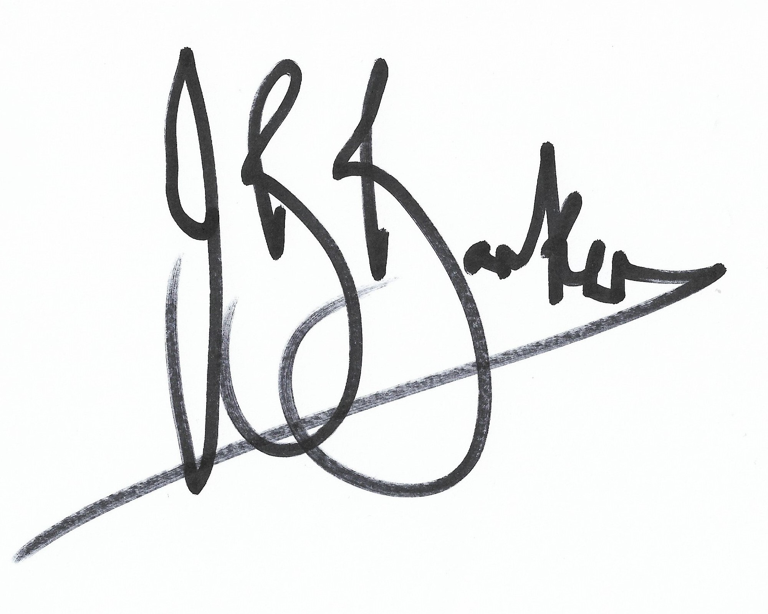
Name of signatory | John Barker
Role of signatory (e.g. chair, director or owner) | Chair

